Mysterious Time Door
Developer –Rita su (YuTing Su)
Genre - 2D Platformer
Game Engine – Unreal 4.27
Intended Audience: 12+
PC

Elevator Pitch

cross secret underground bases and traverse the developing iron ore belt. Find the mysterious shuttle doo

High Concept(Game Description)

Mysterious Time Door is a Fantasy, adventure of game, 2D- side-scrolling - platformer about a high-tech mining company that has unearthed a Mysterious magnetic field deep in the earth. A lot of people have disappeared in that mysterious magnetic field. So the company sealed off the lode. But this mysterious magnetic field is rumored to contain a treasure that could grant a person's wish. The hero realizes his wish and enters this forbidden area.
The gameplay will be inspired by games like New Super Mario Bros and others
Players will use the second leg jump, wall jump and other techniques to traverse lava, spike mechanism, etc. I also modeled the way most games are played on how the difficulty of the game progresses

Levels
Section 1
The player first jumps and double-jumps through the spikes. Use the supporting wall to jump up to another elevated platform, where the player will once again traverse the spike mechanism, but there are not many places where the player can step. Beyond the mechanism is a check point, which is a cliff into the depth of the mining hole.

Section 2
Down a cliff, at the bottom of which is lava and a few trampling rocks. Players need to find a rock to step on before falling into the lava. What lies ahead will strangle all gears and magma. There will be fewer platforms to step on in these mechanisms than in section1.And player need to be careful to using the double jump and wall jump , compare to the section one, it will be harder.
Section 3 –
It was continue the section2 , but the jump will be harder. Player need to directly use double jump, the double jump cannot use too fast

Section 4-
Player need to climb into another area, , using the double jump(the most far away jump to get to the platform), single jump and wall jump to complete the section.

Section5-
After the climbing the platform, it will have a giant fall , during the fall it will have 3 platform with some trap, player can use the wall slide to avoid the trap.

Section6
Their is a gravel under that was the magma. Play need to use single jump to arrive to another platform.

section7-
player need to using the wall jump and double jump combination to avoid the trap in the platform. After that the player will find the mysterious time door(game end).

Reference
- M

DDraceNetwork

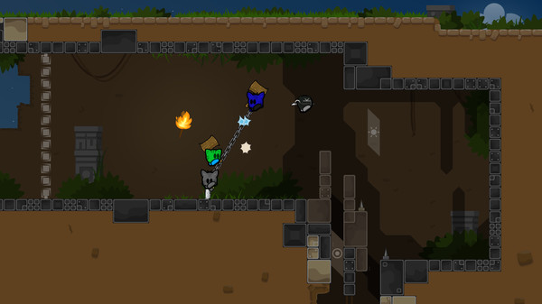

Axiom Verge 2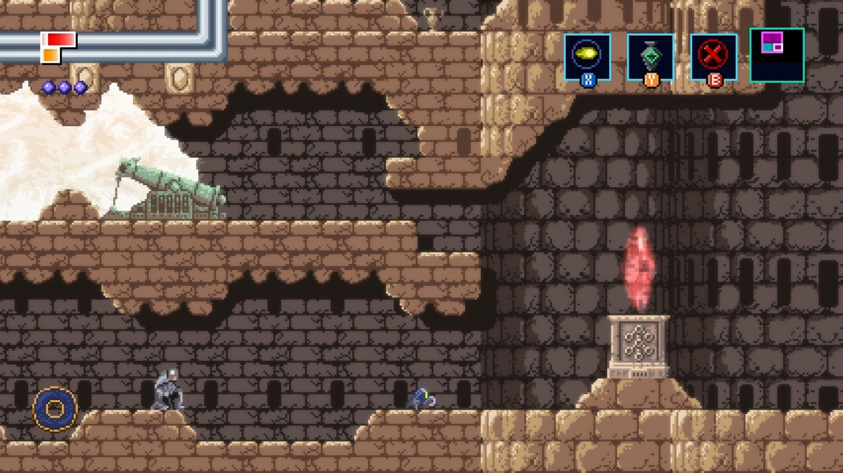

Super Mario
